Slice & Dice
Pizza Sales Data Analysis & Visualization
PROJECT DOCUMENTATION

By Ranjani M K

Table of Contents

1 | Introduction & Business Context
2 | Problem Statement
3 | Project Goals
4 | Data Overview & Tech Stack
5 | Data Preprocessing & Cleaning using SQL
6 | Analysis Results, Visualization and Dashboard
7 | Exploratory Data Analysis (EDA) using SQL
8 | Exploratory Data Analysis and Business Insights
9 | Final Recommendations & Conclusion

- Introduction

This project dives deeper into a pizzeria’s sales data and helps us understand what makes the business function successfully. Every time a customer purchases a pizza, a lot of details are recorded in the transaction like the pizza name, size, category and its cost.

By analyzing the pizza sales information, we can spot the patterns and trends that help us understand the business better and by analyzing and understanding the dataset we can find ways to make the pizza sales business more successful.

Business Context
Running a pizza business isn’t just about cooking great food but it is also about making smart decisions for the business to run successfully. Particularly good business decisions must be made after analyzing the data regarding the following:
- Which category of pizza brings in more money? This information also helps us to make key decisions for buying items as a part of inventory management.
- Which category of pizza is not very popular? This information will help us to decide whether to continue cooking this pizza in future.
- On which days and hours are the pizzeria busiest? This information helps the managers to allocate the right number of staff.

- Problem Statement

The pizza restaurant is currently operating on guesswork. They just know that customers come, order food and make the payment. They know that some categories of food are hot favorites while others are not. But they don’t know the details like how much food is wasted and which is the most unpopular pizza and which are the peak hours for customer visits. We need accurate and complete information with context, to better run the pizza restaurant business.

To maximize the revenue and customer satisfaction, we should make use of the pizza sales dataset for analysis and decide upon the following three critical areas of management in the pizza sales business:
- SALES: Which pizzas drive revenue, and which are underperforming?
- STAFFING: When are the peak hours and peak days that require more kitchen staff?
- INVENTORY MANAGEMENT: What are the most popular pizzas and pizza sizes? This information will help us optimize supply ordering.

- Project Goals

In this pizza sales data analysis project, our main goals will be to gain insights into the following and to produce good business decisions:

- Which pizzas are the top sellers, and which ones should we consider removing from the menu?

- What are the busiest days and hours of the week?

- What size and category of pizza do customers prefer the most?

- What are all the categories of pizzas from the Pizza Sales Database?

- What are all the categories of pizzas and list out the pizza names under each category?

- What are all the pizza sizes available?

- Give out all the distinct pizza names and the many sizes in which they are available?

- What is the first order date and the last order date? What is the total number of days between these orders?

- What is the Total Revenue?

- What is the total number of pizzas sold?
- What is the average price of pizzas?

- What is the total number of orders?

- What is the total number of pizzas?

- What are the key metrics of business?

- What are the total orders by pizza category?

- What is the total number of pizzas by pizza category?

- What is the average cost by pizza category?

- What is the total revenue generated by each category?

- What is the total quantity of pizzas sold by each category?

- Which five pizzas generate the highest revenue?

- What are the five worst performing pizzas in terms of sales?

- Display the pizza ranking.

- Estimate the pizza demand based on immediate past trend.

- Data Overview & Tech Stack

- Dataset Summary

The dataset was downloaded from Kaggle. It is a pizza sales dataset. It tracks the data for individual pizzas that were sold.

Total Number of Records: 2036
Total Number of Columns: 12
Datatypes Included: INTEGER, DECIMAL, VARCHAR, DATE, TIME

- Data Structure & Columns

The columns in the dataset are 12 in number and can be divided into four logical categories and they are as follows:

- Order and Transaction Identifiers

Fields | Data Type | Description
pizza_id | int | A unique ID for each individual pizza row in the dataset.
order_id | int | A unique ID linking multiple pizzas bought together in a single checkout transaction.

- Product and Menu Information

Fields | Data Type | Description
pizza_name_id | varchar() | The identifier for the specific pizza type.
pizza_name | varchar() | The official, customer-facing name of the pizza.
pizza_category | enum() | The menu grouping.
pizza_size | char() | The size of the pizza offered.
pizza_ingredients | varchar() | A comma-separated list of the toppings used on that specific pizza.

- Time and Date Fields

Fields | Data Type | Description
order_date | date | The day the purchase was made (YYYY-MM-DD).
order_time | time | The exact time, the order was placed (HH:MM:SS).

- Financials and Quantities

Fields | Data Type | Description
quantity | int | The number of items of this exact pizza size/type ordered in this specific line.
unit_price | decimal() | The cost of a single pizza.
total_price | decimal() | Calculated per row as:  quantity * unit_price

- Database Schema

Conceptual Database Schema

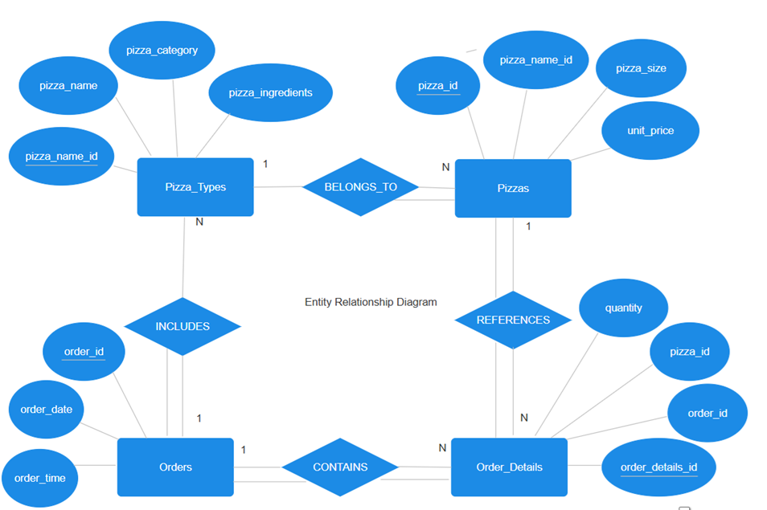

In the above ER diagram, there are four entities which are represented each by a rectangle. These four entities are the four database tables. The oval shape symbols connected to each entity are their respective attributes. The underlined attributes represent the primary keys of the respective database tables.

Types of Relationship between the Tables:

- Pizzas to Pizza_Types: They share a many-to-one relationship. Many pizzas can belong to a single category like Chicken.
- Order_Details to Pizzas: They share a many-to-one relationship. Many Order_Details can reference the same pizza_name_id like Hawaiian_m.
- Orders to Order_Details: They share a one-to-many relationship. A single order can be placed for pizzas of different sizes and numbers. For example, I can place a single order of three pizzas wherein two pizzas are of size L and one pizza is of size S.
- Orders to Pizza_Types: They share a one-to-many relationship. Many pizzas of different categories and of different ingredients can be placed in a single, unique order.

- Logical Database Schema

In this section, we describe the various tables with their table names, attributes and datatypes. There are about 4 tables with the names: Pizza_Types, Pizzas, Orders and Order_Details. The prefix PK in front of an attribute signifies that the attribute is a primary key. And the prefix FK in front of an attribute signifies that the attribute is a foreign key.

Pizza_Types

Attribute | Datatype
PK pizza_name_id | varchar(45)
pizza_name | varchar(255)
pizza_category | enum()
pizza_ingredients | varchar(500)

Pizzas

Attribute | Datatype
PK pizza_id | int
FK pizza_name_id | varchar(45)
pizza_size | char(1)
unit_price | decimal(10,2)

Orders
Attribute | Datatype
PK order_id | int
order_date | date
order_time | time

Order_Details

Attribute | Datatype
PK order_details_id | int
FK order_id | int
FK pizza_id | int
quantity | int

- Software Specifications

Tools Used:

- MySQL Server
- MySQL Workbench
- Power BI Desktop

Programming Language Used:
- SQL

- Implementation 1: Data Cleaning

- Downloaded the dataset from Kaggle.
- Completed data cleaning on the dataset using MySQL.
- Ran SQL queries on the dataset for analyzing the Pizza Sales Business.
- Finally visualized the data and developed a dashboard using Power BI.

- Implementation 2: Exploratory Data Analysis
- Normalized the Cleaned Pizza Sales Analysis Dataset into many tables.
- Performed Exploratory Data Analysis on the same using MySQL.

- Data Preprocessing & Cleaning using SQL

Below are the data cleaning steps that I followed to produce clean analysis regarding Pizza Sales.

STEPS:
- Imported the Pizza Sales Dataset into MySQL Workbench.
- Care was taken to import order_date column as VARCHAR() and was later changed to DATE data type. This method was followed to successfully import order_date column without issues.
- Cleaned the order_date column. Used IS NOT NULL, IS NULL, TRIM(order_date) to fix the data. Formatted the order_date column values to YYYY_MM_DD format.
- Modified unit_price column and total_price column to DECIMAL(10,2).
- Replaced $ signs/symbols in unit_price and total_price columns with a space.
- Performed Math Sanity Check on the column total_price to ensure that quantity * unit_price = total_price.
- Modified the order_time column to TIME datatype.
- Checked for anomalies in the order timings. This ensured that all orders were placed between 11 AM to 10 PM during the Pizzeria’s working hours.
- Checked for duplicate values in the pizza_id column. This ensures that your total pizza count won’t be artificially inflated.
- Standardized the pizza_name_id column by updating pizza_name_id = TRIM(LOWER(pizza_name_id)); The names in this column ended with _m and _l wherein _m signifies that the pizza is of medium size and _l signifies that the pizza is of large size. Any space like Hawaiian m, will suggest that hawaiian m is a different pizza type. To ensure correctness we use this step.
- The pizza_ingredients column contains comma separated values. Hidden spacing in this column was cleaned.
- Performed a NULL AUDIT check on the columns pizza_id, order_id, quantity and total_price. Presence of NULL values will make the data dirty, and it will skew our analysis. This NULL AUDIT check made sure that there were no NULL values in the columns.
- Standardized categorical fields like pizza_size, pizza_category and pizza_name that are present in the dataset. It is important to standardize the values of these columns in order to come up with accurate analysis. Standardized the sizes. Made sure only M, L and S pizza sizes are present because sometimes text imports mess up with casing and spaces. Hence, we need to standardize them. Also ensured that the pizza_category column values are uniformly capitalized.

- Analysis Results, Visualization and Dashboard

Some important analysis that I came up with after data cleaning are as follows:

- Sales Performance Analysis

The following KPIs or Key Performance Indicators were tracked:

- Total Revenue: The Total Revenue generated was 34.13K dollars.

- Average Order Value: It tells how much customers spend per order on average? It was found that customers spent an average of 37.26$ per order. It is the Average Order Value.

- Total Pizzas Sold: It is the sum of the quantities. It was found that nearly a total of 2K pizzas were sold.

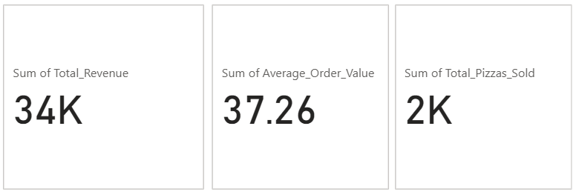

- Time-Based Analysis

With Time-Based Analysis, we tracked the following information:

- Daily Trend for Total Orders: From the chart below, we notice that Thursdays were the favorite days for ordering pizzas.

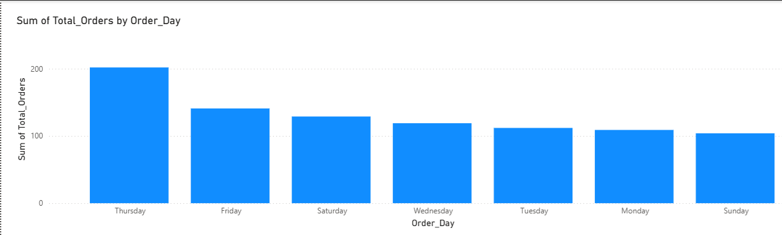

- Hourly Trend for Total Orders: From the chart below, we notice that the peak pizza ordering hours are at 12 noon and at 6 PM in the evening.

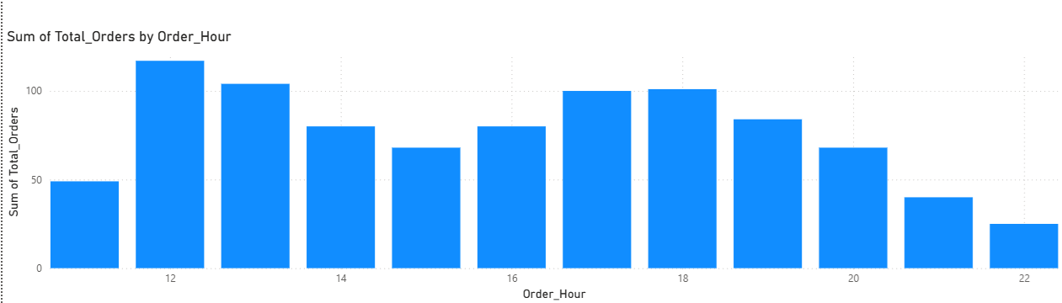

- Product and Category Analysis

The donut and pie charts below help us understand how the business runs based on various dimensions like Pizza Category and Pizza Size. The information below can help us make good business decisions.

- Percentage of sales by Pizza Category

From the donut chart below, it can be observed that each Pizza Category contributes to nearly 25 % of Pizza Sales.

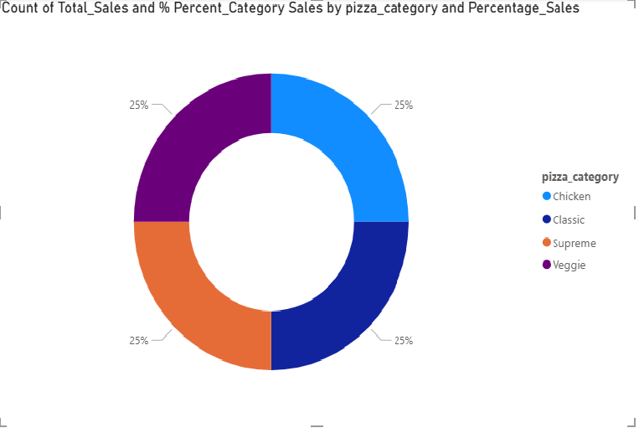

- Total Sales by Pizza Size

From the pie chart below, it can be observed that pizza size L (Large) contributes to about 47.63 % of sales, which is the largest. Followed by pizza size M (Medium), which contributes to about 31.74% of sales and lastly the pizza size S, which is small, contributes to about 20.62% of pizza sales.

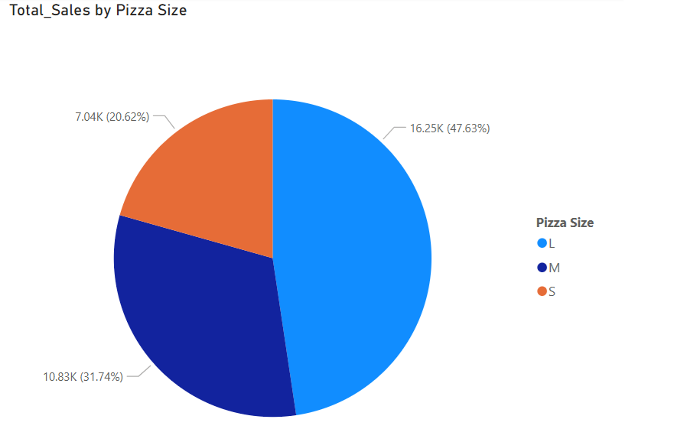

- Top 5 best sellers by revenue

The table below shows the Top 5 Pizzas that contributed maximum to the Pizzeria’s Revenue.
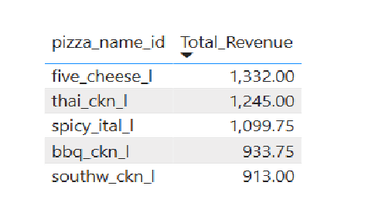

Based on the clean pizza sales dataset and analysis results above, a Pizza Sales Analysis Dashboard has been created using Power BI. The dashboard has 4 pages. First page is dedicated to Pizza Sales Analysis. Second page is dedicated to Sales Performance Analysis. Third page is dedicated to Time-Based Analysis and the fourth page is dedicated to Product and Category Analysis.

- Exploratory Data Analysis (EDA) using SQL

To further understand the Pizza Sales Business better, we dive deeper into analyzing by applying Exploratory Data Analysis to the Pizza Sales Database using SQL programming language.

To continue with Exploratory Data Analysis, the Pizza Sales dataset was first cleaned and secondly normalized into many tables. This is again a pure SQL-Driven Exploratory Analysis.

There are four normalized tables used for this analysis. Below are the 4 tables with their attribute names and datatypes.

Pizza_Types

Attribute | Datatype
PK pizza_name_id | varchar(45)
pizza_name | varchar(255)
pizza_category | enum()
pizza_ingredients | varchar(500)

Pizzas

Attribute | Datatype
PK pizza_id | int
FK pizza_name_id | varchar(45)
pizza_size | char(1)
unit_price | decimal(10,2)

Orders
Attribute | Datatype
PK order_id | int
order_date | date
order_time | time

Order_Details

Attribute | Datatype
PK order_details_id | int
FK order_id | int
FK pizza_id | int
quantity | int

Entity-Relationship Diagram

Below is the Entity- Relationship Diagram for the normalized Pizza Sales Database. It is known as Crow’s Foot Notation.

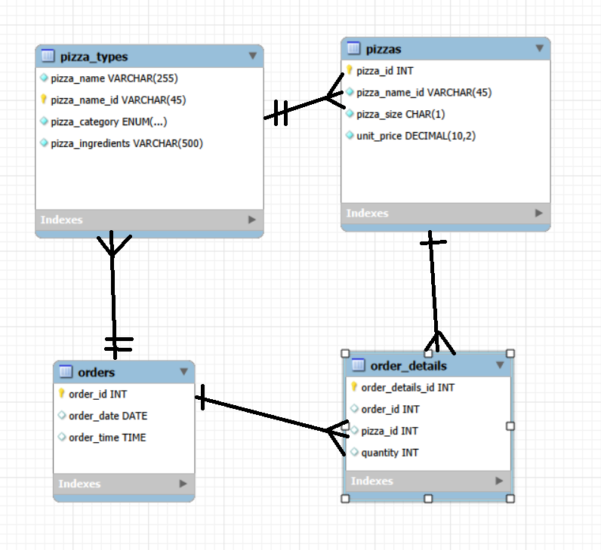

Crow’s Foot Notation Explanation:

It is essentially used to explain the Entity-Relationship Diagram, wherein the diagram maps out the relationship between various tables/entities in a database showing the cardinality between the relationships. Below are the cardinality relationships explained along with their symbols.

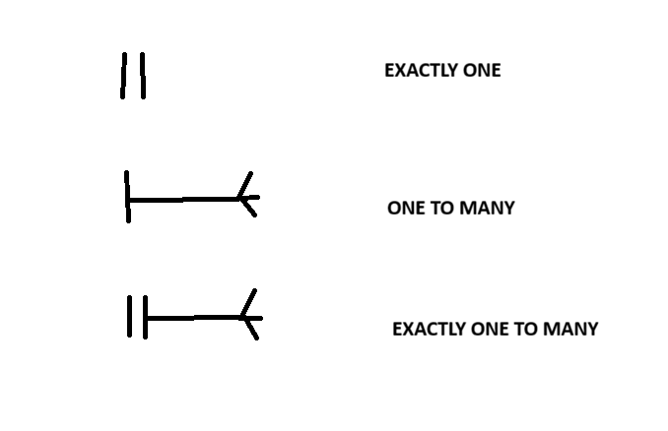
In the above ER-Diagram, you can notice the above symbols drawn between tables, which tell us that the tables are connected. Each rectangular box represents an entity. The entities/tables in the diagram are as follows:
- pizza_types
- pizzas
- orders
- order_details

The other elements present inside the rectangular box are the attributes of the respective tables.

Data Cleaning and Preparation

- The Pizza Sales Dataset used for Exploratory Data Analysis is a clean dataset.

- NULL values were removed.

- The order_date and order_time column were converted to the DATE and TIME formats, respectively.

- Duplicates were handled in the dataset.

- Exploratory Data Analysis and Business Insights

Dimensions Exploration
This section deals with exploring the various dimensions in the Pizza Sales Database.

- What are all the categories of pizzas from the Pizza Sales Database?

SQL Query

SELECT DISTINCT(pizza_category)
FROM pizza_types

Result:

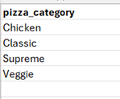

Insight: From the above table, we notice that there are four pizza categories. And they are Chicken, Classic, Supreme and Veggie.

- What are all the categories of pizzas and also list out the pizza names under each category?

SQL Query

SELECT DISTINCT pizza_category, pizza_name
FROM pizza_types

Result:

pizza_category | pizza_name
Chicken | The Barbecue Chicken Pizza
Classic | The Big Meat Pizza
Supreme | The Brie Carre Pizza
Supreme | The Calabrese Pizza
Chicken | The California Chicken Pizza
Chicken | The Chicken Alfredo Pizza
Chicken | The Chicken Pesto Pizza
Classic | The Classic Deluxe Pizza
Veggie | The Five Cheese Pizza
Veggie | The Four Cheese Pizza
Veggie | The Green Garden Pizza
Classic | The Hawaiian Pizza
Classic | The Italian Capocollo Pizza
Supreme | The Italian Supreme Pizza
Veggie | The Italian Vegetables Pizza
Veggie | The Mediterranean Pizza
Veggie | The Mexicana Pizza
Classic | The Napolitana Pizza
Classic | The Pepperoni, Mushroom, and Peppers Pizza
Classic | The Pepperoni Pizza
Supreme | The Pepper Salami Pizza
Supreme | The Prosciutto and Arugula Pizza
Supreme | The Sicilian Pizza
Supreme | The Soppressata Pizza
Chicken | The Southwest Chicken Pizza
Supreme | The Spicy Italian Pizza
Veggie | The Spinach Pesto Pizza
Veggie | The Spinach and Feta Pizza
Supreme | The Spinach Supreme Pizza
Chicken | The Thai Chicken Pizza
Classic | The Greek Pizza
Veggie | The Vegetables + Vegetables Pizza

Insight: From the above table, we notice that each of the four pizza categories offer different types of pizzas that are called by different names.

- What are all the pizza sizes available?
SQL Query

SELECT DISTINCT(pizza_size)
FROM pizzas

Result:

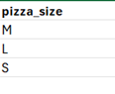

Insight: The above table tells us that the pizzeria offers pizzas only of three sizes and they are M – Medium, L – Large and S – Small.

- Give out all the distinct pizza names and the many sizes in which they are available?

SQL Query

SELECT DISTINCT pizza_name_id, pizza_size
FROM pizzas

Result:

pizza_name_id | pizza_size
hawaiian_m | M
classic_dlx_m | M
five_cheese_l | L
ital_supr_l | L
mexicana_m | M
thai_ckn_l | L
ital_supr_m | M
prsc_argla_l | L
bbq_ckn_s | S
the_greek_s | S
spinach_supr_s | S
classic_dlx_s | S
green_garden_s | S
ital_cpcllo_l | L
ital_supr_s | S
mexicana_s | S
spicy_ital_l | L
spin_pesto_l | L
veggie_veg_s | S
mexicana_l | L
southw_ckn_l | L
bbq_ckn_l | L
cali_ckn_l | L
cali_ckn_m | M
pepperoni_l | L
cali_ckn_s | S
ckn_pesto_l | L
big_meat_s | S
soppressata_l | L
four_cheese_l | L
napolitana_s | S
calabrese_m | M
four_cheese_m | M
ital_veggie_s | S
mediterraneo_m | M
peppr_salami_s | S
spinach_fet_l | L
napolitana_l | L
sicilian_l | L
ital_cpcllo_m | M
southw_ckn_s | S
bbq_ckn_m | M
pepperoni_m | M
prsc_argla_s | S
sicilian_m | M
veggie_veg_l | L
ckn_alfredo_s | S
pepperoni_s | S
green_garden_l | L
green_garden_m | M
pep_msh_pep_l | L
hawaiian_s | S
peppr_salami_m | M
ckn_alfredo_m | M
peppr_salami_l | L
spin_pesto_s | S
thai_ckn_m | M
classic_dlx_l | L
ckn_pesto_m | M
hawaiian_l | L
pep_msh_pep_s | S
spinach_supr_m | M
prsc_argla_m | M
mediterraneo_l | L
southw_ckn_m | M
pep_msh_pep_m | M
sicilian_s | S
spicy_ital_s | S
thai_ckn_s | S
spinach_supr_l | L
ital_veggie_l | L
veggie_veg_m | M
the_greek_m | M
ckn_pesto_s | S
spinach_fet_s | S
spicy_ital_m | M
ital_veggie_m | M
ital_cpcllo_s | S
mediterraneo_s | S
spinach_fet_m | M
napolitana_m | M
spin_pesto_m | M
brie_carre_s | S
ckn_alfredo_l | L
calabrese_s | S
the_greek_l | L
soppressata_m | M
soppressata_s | S
calabrese_l | L

Insight: The above table lists all the unique pizzas available in the pizzeria with their respective sizes, each of M, S and L.

Date Exploration

This section deals with date exploration.

- What is the first order date and the last order date? What are the total number of days between these orders?

SQL Query

SELECT MIN(order_date) as first_order_date,
MAX(order_date) as last_order_date,
DATEDIFF(MAX(order_date),MIN(order_date))as Total_No_of_Days_between_Orders
FROM orders

Result:

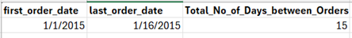

Insight: The above result conveys when the first pizza order was placed and also conveys when the last pizza order was placed. It also gives out the total number of days that passed between these pizza orders.

Measures Exploration
This section deals with calculating the key metrics of the business by applying aggregate functions.

- What is the Total Revenue?

SQL Query

SELECT SUM(od.quantity * p.unit_price) as Total_Revenue
FROM pizzas as p inner join order_details as od
on p.pizza_id=od.pizza_id

Result:

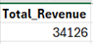
Insight: The above result gives out the total revenue earned by the pizzeria.

- What are the total number of pizzas sold?

SQL Query

SELECT SUM(quantity) as Total_Quantity
FROM order_details

Result:

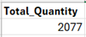

Insight: 2,077 were the total number of pizzas sold by the Pizzeria.

- What is the average price of pizzas?

SQL Query

SELECT AVG(unit_price) as Average_Price
FROM pizzas

Result:

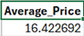

Insight: The above result tells us that the average price of each pizza that was sold is nearly 16$.

- What are the total number of orders?

SQL Query

SELECT COUNT(DISTINCT order_id) as Total_Orders
FROM orders

Result:

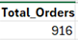

Insight: The total number of orders that were placed for pizzas in the pizzeria was 916.

- What is the total number of pizzas?

SQL Query

SELECT COUNT(DISTINCT pizza_id) as Total_No_of_Pizzas
FROM pizzas

Result:

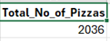

Insight: The total number of available pizzas in the pizzeria is 2,036.

Report on Key Metrics of the Business

Below is the SQL Code used for generating the report to show the Key Metrics of the Business:

SELECT 'Total Sales' as measure_name, SUM(od.quantity * p.unit_price) as measure_value
FROM pizzas as p inner join order_details as od
on p.pizza_id=od.pizza_id
UNION ALL
SELECT 'Total Quantity' as measure_name, SUM(quantity) as measure_value
FROM order_details
UNION ALL
SELECT 'Average Price' as measure_name, AVG(unit_price) as measure_value
FROM pizzas
UNION ALL
SELECT 'Total Orders' as measure_name, COUNT(DISTINCT order_id) as measure_value
FROM orders
UNION ALL
SELECT 'Total No. of Pizzas' as measure_name, COUNT(DISTINCT pizza_id) as measure_value
FROM pizzas

Result:

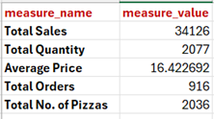

Insight: The result we see above is a report generated showing the key metrics of the business. These numbers are some of the most crucial numbers to be monitored in the pizza sales business as it helps us decide on inventory management and waste management by closely monitoring how many pizzas were sold and how many pizzas could not be sold.

Magnitude Analysis for Insights

This section is about comparing the measure values by categories. It helps us understand the importance of various categories.

- What are the total orders by pizza category?

SQL Query

SELECT pizza_category, COUNT(order_id) as Total_Orders
FROM order_details, pizza_types
GROUP BY pizza_category
ORDER BY Total_Orders DESC

Result:

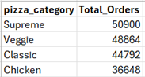

Insight: The above result gives us the total number of orders per pizza category.

- What is the total number of pizzas by pizza category?

SQL Query

SELECT pizza_category, SUM(pizza_id) as Total_Pizzas
FROM pizza_types as pt inner join pizzas as p
on pt.pizza_name_id = p.pizza_name_id
GROUP BY pizza_category
ORDER BY Total_Pizzas DESC

Result:

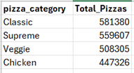

Insight: The above result shows us the total number of pizzas present in each
category.

- What is the average cost by pizza category?

SQL Query

SELECT pizza_category, AVG(unit_price) as Average_Cost
FROM pizza_types as pt inner join pizzas as p
on pt.pizza_name_id = p.pizza_name_id
GROUP BY pizza_category
ORDER BY Average_Cost DESC

Result:

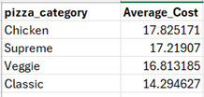

Insight: The above result shows us the average cost of a pizza per category. Chicken and Supreme category pizzas have average cost higher than Veggie and Classic.

- What is the total revenue generated by each category?

SQL Query

SELECT pt.pizza_category, SUM(od.quantity * p.unit_price) as Total_Revenue
FROM order_details as od inner join pizzas as p
on od.pizza_id = p.pizza_id
inner join pizza_types as pt
on p.pizza_name_id = pt.pizza_name_id
GROUP BY pt.pizza_category
ORDER BY Total_Revenue DESC

Result:

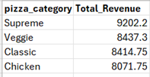

Insight: The above result summarizes the total revenue earned by each pizza
category.

- What is the total quantity of pizzas sold by each category?

This SQL Query provides us with insights into the distribution of sold pizzas across categories.

SQL Query

SELECT pt.pizza_category, SUM(od.quantity) as Total_Quantity_Sold
FROM pizzas as p inner join pizza_types as pt
on p.pizza_name_id=pt.pizza_name_id
inner join order_details as od
on p.pizza_id = od.pizza_id
GROUP BY pt.pizza_category
ORDER BY Total_Quantity_Sold

Result:

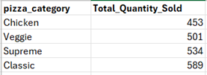

Insight: From the above result, we realize that Classic category pizza is the largest by quantity sold. Followed by Supreme, Veggie and Chicken.

Ranking Analysis

- Which 5 pizzas generate the highest revenue?

SQL Query

SELECT pt.pizza_name, SUM(od.quantity * p.unit_price) as Total_Revenue
FROM order_details as od inner join pizzas as p
on od.pizza_id = p.pizza_id
inner join pizza_types as pt
on p.pizza_name_id = pt.pizza_name_id
GROUP BY pt.pizza_name
ORDER BY Total_Revenue DESC
LIMIT 5

Result:

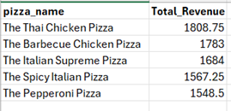

Insight: Out of all the pizza types available, The Thai Chicken Pizza, The
Barbecue Chicken Pizza, The Italian Supreme Pizza, The Spicy Italian Pizza and
The Pepperoni Pizza generates the highest revenue.

- What are the 5 worst performing pizzas in terms of sales?

SQL Query

SELECT pt.pizza_name, SUM(od.quantity * p.unit_price) as Total_Revenue
FROM order_details as od inner join pizzas as p
on od.pizza_id = p.pizza_id
inner join pizza_types as pt
on p.pizza_name_id = pt.pizza_name_id
GROUP BY pt.pizza_name
ORDER BY Total_Revenue ASC
LIMIT 5

Result:

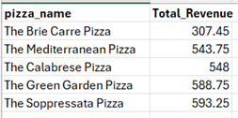

Insight: The five worst performing pizzas in terms of sales are The Brie Carre
Pizza, The Mediterranean Pizza, The Calabrese Pizza, The Green Garden Pizza
and The Soppressata Pizza. These are the slow-moving pizzas and we should
consider offering them along with the hot favorites at a discounted price.

- Display the pizza ranking.

SQL Query

WITH RankedPizzas AS
( SELECT pt.pizza_name, SUM(od.quantity * p.unit_price) AS Total_Revenue,
ROW_NUMBER() OVER (ORDER BY SUM(od.quantity * p.unit_price) DESC) AS rank_pizzas
FROM order_details AS od INNER JOIN pizzas AS p
ON od.pizza_id = p.pizza_id
INNER JOIN pizza_types AS pt
ON p.pizza_name_id = pt.pizza_name_id
GROUP BY pt.pizza_name )

SELECT pizza_name, Total_Revenue, rank_pizzas
FROM RankedPizzas
WHERE rank_pizzas <= 5;

Result:

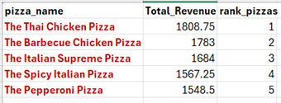

Insight: The above results show the fast-moving pizzas ranked 1 to 5. These
are the favorites and the pizzeria should make sure that they are always in stock.

Forecasting Pizza Demand
The SQL query below calculates the 7 day moving average to project the upcoming Pizza Demand based on immediate past trends.

SQL Query
SELECT order_date, pizza_id, quantity,
AVG(quantity) OVER (PARTITION BY pizza_id ORDER BY order_date ROWS BETWEEN 6 PRECEDING AND CURRENT ROW) as seven_day_demand_forecast
FROM sales

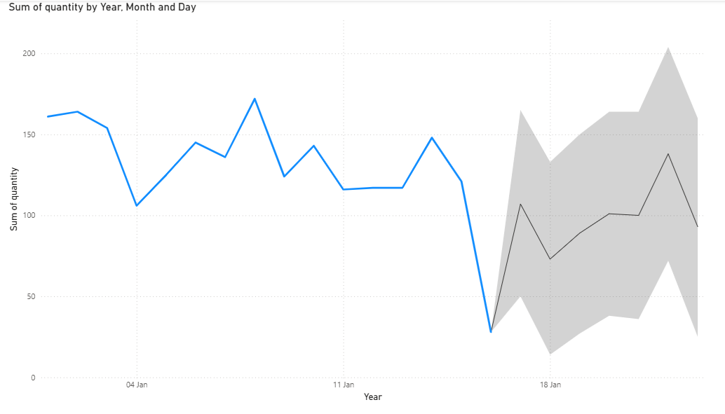

Fig.1

The above figure (Fig.1) depicts the demand of pizzas for the next 7 days. The shaded area represents the 7-day forecast for pizza demand. It shows an upward trend in pizza demand for the future week followed by a slight dip in pizza demand over the weekend.
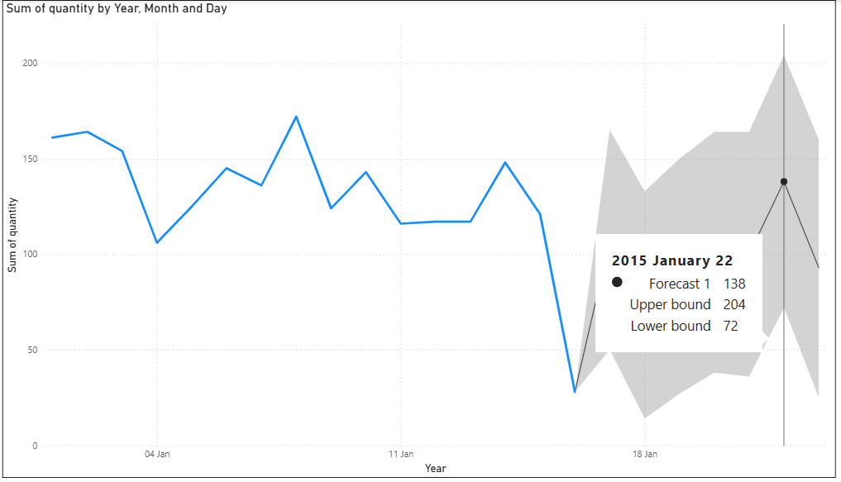
Fig.2
From the Fig.2 above, we realize that the pizza demand has peaked on Thursday, January 22, 2015. The forecast shows the demand for pizzas as 138 on Thursday and it is the highest for the week. The upper bound for pizza demand is 204 and the lower bound for pizza demand is 72.

Based on the analysis, I have realized the following about the Pizza Sales Business:

- The Thai Chicken Pizza belonging to the Chicken category brings in more money compared to other categories. The Thai Chicken Pizza earns 1808.75$ as Total Revenue.

- The Brie Carre Pizza is the most unpopular. It belongs to the Supreme category.

- On Thursdays, the Pizzeria is the busiest and at around 12 noon and 6 PM in the evening, the orders for pizzas peak.

- Pizzas of large size are very popular, and the most popular pizzas are five_cheese_l and thai_ckn_l.

- Final Recommendations & Conclusion

Based on the analysis results, I have come up with the key business decisions regarding the following:

- Staffing Optimization: Increase kitchen staff on Thursdays at 12 noon and at 6 PM in the evening to handle peak order volumes.

- Inventory Management: Since Large pizzas drive the majority of sales, prioritize large-box and large-dough inventory.

- Menu Engineering: Consider bundling unpopular, low-volume pizzas with top-sellers via a promotional discount to clear slower-moving pizzas.

This Data Cleaning and Exploratory Data Analysis project successfully transformed raw pizza sales data into actionable business strategies, identifying Thursdays and Fridays as peak rush days of the week and Large pizzas as our primary growth drivers. By optimizing kitchen staffing during peak days and hours and by adjusting inventory for high-demand sizes, the restaurant can maximize efficiency and cut operational waste. The next step for this project is to connect this MySQL database to a visualization tool like Power BI to build a live performance dashboard.

